***Directions:*** Complete the Questions below (10 points each). Display a snippet of the code and the output below:

**COP2335: Object-Oriented Programming Lab 7**

1. Write a program that will read in grades, the number of which is also input by the user. The program will find the sum of those grades and pass it, along with the number of grades, to a function which has a “pass by reference” parameter that will contain the numeric average of those grades as processed by the function. The main function will then deter- mine the letter grade of that average based on a 10-point scale.

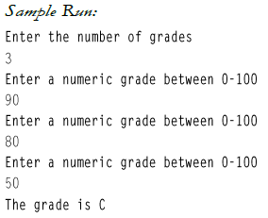

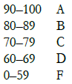

**Snippet of the Code:**

**Snippet of the Output:**

1. Write a program that will read two floating point numbers (the first read into a variable called first and the second read into a variable called second) and then calls the function swap with the actual parameters first and second. The swap function having formal parameters number1 and number2 should swap the value of the two variables.

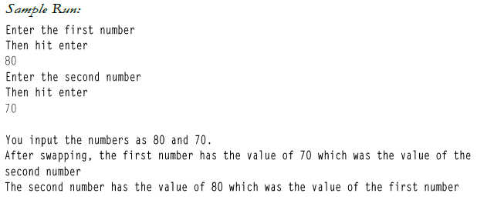

**Snippet of the Code:**

**Snippet of the Output:**

1. Write a program that will input miles traveled and hours spent in travel. The program will determine miles per hour. This calculation must be done in a function other than main; however, main will print the calculation. The function will thus have 3 parameters: miles, hours, and milesPerHour. Which parameter(s) are passed by value, and which are passed by reference? Output is fixed with 2 decimal point precision.

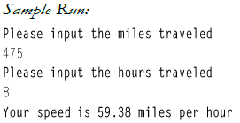

**Snippet of the Code:**

**Snippet of the Output:**

1. Write a program that will input temperatures for consecutive days. The program will store these values into an array and call a function that will return the average of the temperatures. It will also call a function that will return the highest temperature and a function that will return the lowest temperature. The user will input the number of temperatures to be read. There will be no more than 50 temperatures. Use typedef to declare the array type. The average should be displayed to two decimal places.

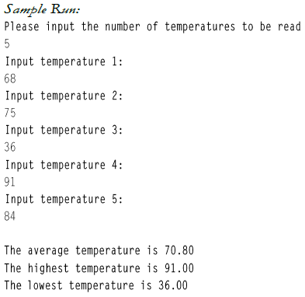

**Snippet of the Code:**

**Snippet of the Output:**

1. Write a program that will input letter grades (A, B, C, D, F), the number of which is input by the user (a maximum of 50 grades). The grades will be read into an array. A function will be called five times (once for each letter grade) and will return the total number of grades in that category. The input to the function will include the array, number of elements in the array and the letter category (A, B, C, D or F). The pro- gram will print the number of grades that are A, B, etc.

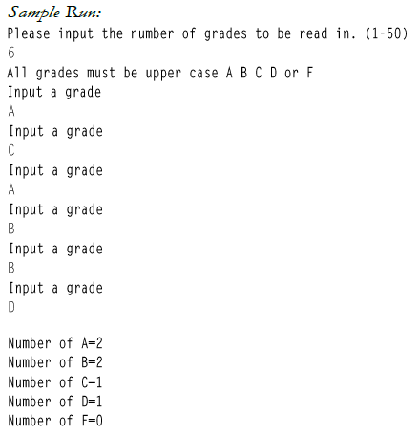

**Snippet of the Code:**

**Snippet of the Output:**

